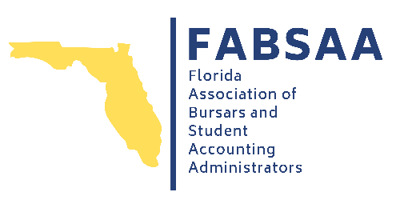

SAVE THE DATE!
22nd Annual Conference

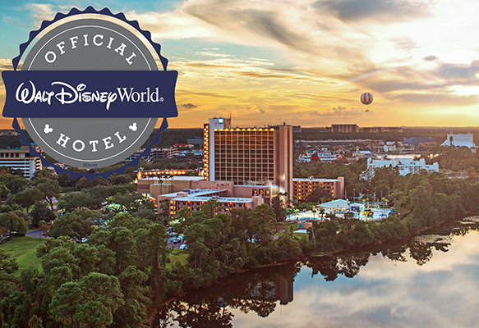

April 23 - April 25, 2025
Wyndham Lake Buena Vista Resort
Orlando, FL

